What are the discrepancies between crisp logic and fuzzy logic?
- The main discrepancy is that crisp logic uses a binary, all-or-nothing approach where a statement is either completely true (1) or completely false (0), while fuzzy logic uses a degree-of-truth system where a statement can be partially true on a scale between 0 and 1.
- This means crisp logic is precise and binary, while fuzzy logic can handle vague or imprecise concepts and uncertainty, such as "tall" or "hot".
- Crisp is bi-valued function logic where as fuzzy is infinite valued function logic

Feature | Crisp Logic | Fuzzy Logic
Truth Value | Binary (0 or 1); either true or false | A value between 0 and 1; a degree of truth
Concept | Clearly defined, exact boundaries | Handles vagueness and uncertainty
Example | A person is either a "tall man" (true=1) or not (false=0) | A person can be "somewhat tall" or "very tall" (e.g., 0.7)
Application | Classical logic, situations with definite data | Control systems, artificial intelligence, pattern recognition where concepts are imprecise
Set Membership | An element either fully belongs to a set or doesn't at all | An element can partially belong to a set

Example:
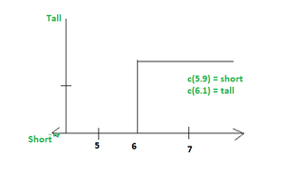
Crisp Set:

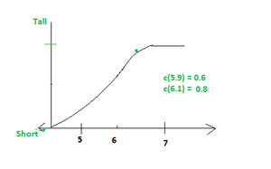
Fuzzy set:

What is the conversion from fuzzy to crisp? (Function of Defuzzification)
- Defuzzification is defined as the process that transforms fuzzy output values from fuzzy logic inference methods into crisp (non-fuzzy) data for practical use.
- This process employs various methods, such as the centroid method, to determine a specific output value from the fuzzy output membership function.

What is a crisp relation and a fuzzy relation?
- Crisp relations are binary relations where the membership is 1 if an element pair is in the relation and 0 otherwise.
- Fuzzy relations allow graded membership between 0-1. Operations like union, intersection and complement can be performed on fuzzy relations.

What are the four parts of fuzzy logic?
- Fuzzy inference process usually includes four parts: fuzzification, fuzzy rules base, inference method, and defuzzification, as shown below.
- Fuzzification: The process of converting specific input values into degree of membership of fuzzy sets via membership functions.
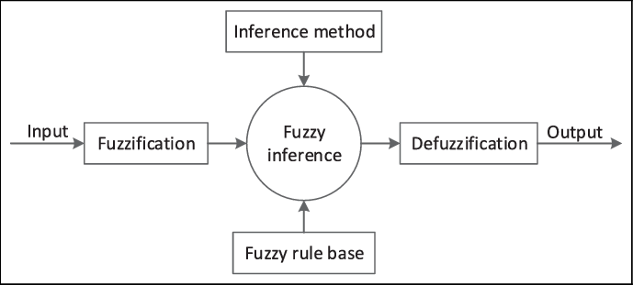

Who is the father of fuzzy logic?
- Lotfi Zadeh is known as the "father of fuzzy logic".

Who is the mother of AI?
- Fei Fei Li is a professor of computer science at Stanford University.

Who is the father of AI?
- John McCarthy is considered the "father of AI".

